Learning Journal Unit 4
- Reflect on the concept of composite and inverse functions. What concepts (only the names) did you need to accommodate these concepts in your mind?
For composite function, I understand the concept by imagining a combination two functions f(x) and g(x) in such a way that the output of one function becomes the input of another is known as a composition of functions. For instance, in fog(x), the output of g(x) becomes the input of f(x) and the reverse is true when working with gof(x) as a composite function. As noted by Abramson (2021), composition operator often denoted by an open circle (o) helps to emphasize the relationship between the two functions combined without referring to any particular input value.
On the other hand, I understand the concept of inverse function by imagining the reverse of a function itself. For example, the reverse of addition is subtraction, where the addition sign can be used to work out the output of a function and the subtraction used to work out input of a function.
- What are the simplest composite and inverse functions you can imagine?
The simplest composite function is fog(x)=x when f(x)=x and g(x)=x. on the other hand, the simplest inverse function is f^-1(x)=x when f(x)=x.
- In your day to day, is there any occurring fact that can be interpreted as composite and inverse functions?
For function, we often apply the concept of composite functions in kinematics when deriving the equations of motion with uniform acceleration. For instance the function defining distance can be s(t)=(u+v)t/2 and v(t)=u+at. To find the composite function s(v), which combines s(t) and v(t), we'll start by expressing s(t) and v(t) in terms of v. Then, we'll substitute the expression for v in s(t) to obtain s(v) as follows:
Given s(t) = (u + v)t/2 and v(t) = u + at, first, we begin by expressing s(t) in terms of v: s(t) = (u + v)t/2
Now, we need to find t in terms of v from v(t): v(t) = u + at
Solve for t: at = v – u which leads to t = (v - u)/a
Now, substitute this expression for t in s(t): s(v) = [(u + v)((v - u)/a)]/2
Now, simplify the expression: s(v) = [(u + v)(v - u)]/(2a)
Expanding the expression in the numerator: s(v) = [uv - u² + v² - uv]/(2a)
Now, combine like terms in the numerator: s(v) = (v² - u²)/(2a)
So, the composite function s(v) is: s(v) = (v² - u²)/(2a)
This is the composite function that relates the displacement (s) and velocity (v) of an object with initial velocity (u) and acceleration (a).
For inverse function, it can be applied in economics to model the relationship between supply and demand. Inverse functions allow economists to analyze how changes in demand or supply, due to factors like changes in consumer preferences, production costs, or government policies, affect market prices and quantities. By understanding the inverse relationship between supply and demand functions, economists can make predictions and recommendations about market behavior, pricing strategies, and policy interventions to achieve desired economic outcomes.
Demand Function: The demand function is typically a decreasing function, meaning that as the price increases, the quantity demanded decreases.
Supply Function: The supply function is typically an increasing function, meaning that as the price increases, the quantity supplied increases.
Equilibrium: In a competitive market, the price and quantity will settle at a point where the demand and supply functions intersect. This point is known as the market equilibrium. At this price, the quantity demanded equals the quantity supplied.
Inverse Functions: Inverse functions come into play when economists want to find the price at which the market is in equilibrium. They essentially solve for the price where D(p) = S(p), which is the point where the functions are inverses of each other. This equilibrium price is crucial for understanding market dynamics. Refer to the graph below.
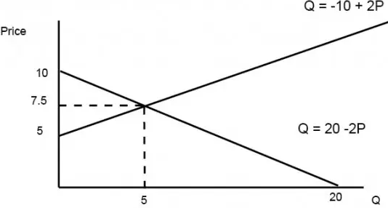
Source: Economics Help, 2023
- What strategy are you using to get the graph of composite and inverse functions?
When graphing composite and inverse functions, I will be interested to obtain their domain and range which will be used to graph composite functions. For graph of inverse function, the line y=x would be crucial.

Reference
Abramson, J. (2021). Algebra and trigonometry (2nd ed.). OpenStax, TX: Rice University. Retrieved from https://openstax.org/details/books/algebra-and-trigonometry-2e
Economics Help. (2023). How to determine supply and demand equilibrium equations. https://www.economicshelp.org/blog/glossary/how-to-determine-supply-and-demand-equilibrium-equations/

